**Christopher Coen | Michael Flett | Seth Ramey | Jakob Wagner | Dirk Stathers**

**Midterm Status Report**

**Level of Completion**:

* Utilization of Selenium (or like tool) to scrape information regarding Out of Service (OoS) carriers in Indiana. - **100%**
* Data is to be cleaned and made available in an online database alongside Geocode retrieved through an API. - **100%**
* Geocode location, company names, address, and/or contact persons are to be compared to flag possible reincarnated trucking companies with companies from a provided database. - **70%**
* An attractive, functional web interface is to be developed. It will probably utilize menus, breadcrumbs, footers, and sitemaps. - **65%**
* Displayed lists of legitimate trucking companies and potential chameleons. - **50%**
* Display legitimate trucking companies and potential chameleons. - **33.33%**
* Search for and display by name, USDOTNum, and/or contact number. - **100%**
* Potential chameleon companies within a geofence area to be displayed. - **70%**
* Testing. - **0%**
* Confidence level - in reference to the portion of the code/tables that measures our confidence that any one company is a chameleon. - **40%**

**Individual User Grades:** Brought to you by a peeved Scrum Master after finding out that QA actively ignored his section of the document.

* **Michael Flett, Seth Ramey, Jakob Wagner**: A - For going above and beyond the requirements of their individual roles and maintaining active communication.
* **Chris Coen**: C or B - For doing the bare minimum of his role a B, for not being able to wrangle QA into doing his job a C.
* **Dirk Stathers**: D - For only doing the bare minimum of his position, as far as Written Grade Reports go, while blatantly ignoring the other portions of his duty and claiming repeatedly that he *can’t do it cause there’s nothing for him to test* when this is blatantly a lie. Why he signed up for a position that is required to write automated tests when the alternative position available was one where all he had to do was write reports, nobody knows.

**Amount of Data Stored/Processed/Cleaned**:

* About 1500 records in LiquidatedCompanies Table.
* About 37,000 records in TruckingCompanies Table.
* About **X** records in ChameleonCompanies Table. (Comparison is in testing, no records actively available. Will come back to this one when there’s something to put here.

**Cool Things to Report**:

* Map actually functions

**Significant Problems**:

* Connecting the database to the javascript of the map
* Getting the points from the table to focus on the map

**Shots of Code**:

Allows for placing of multiple markers and creates the 50 mile radius if you go through the table and select a specific point or if the map tab is clicked it will display all data

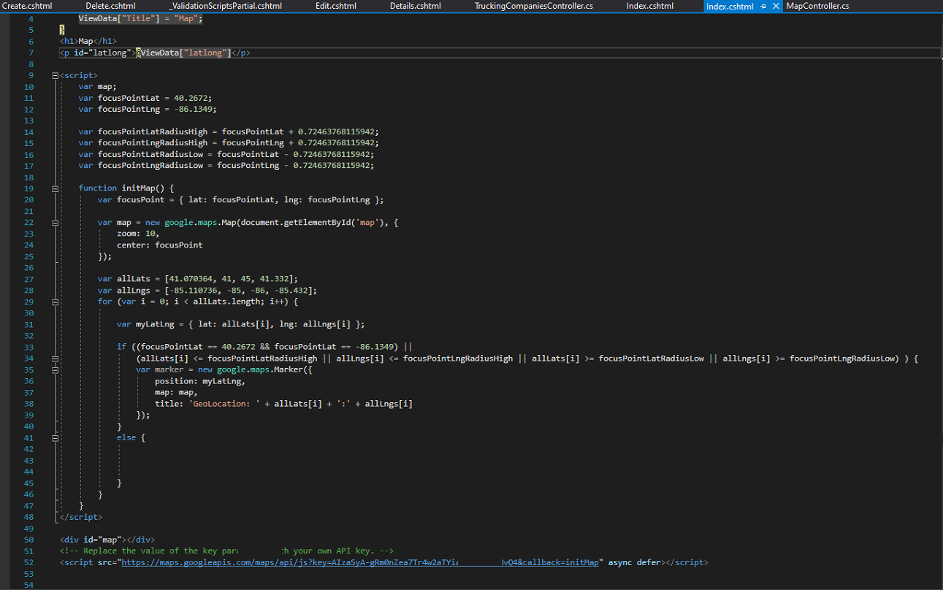

GeoLocation Code

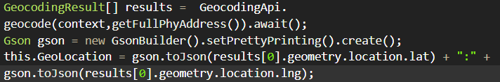

ClearData() method to clear the data inside the class without making an entirely new object

(It isn’t revolutionary but it's nice for optimization)

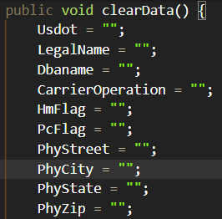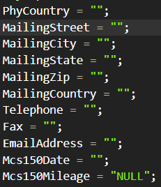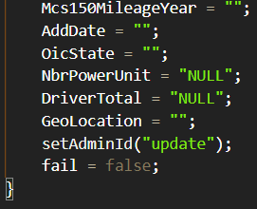

Code adds records to the LiquidatedCompanys table

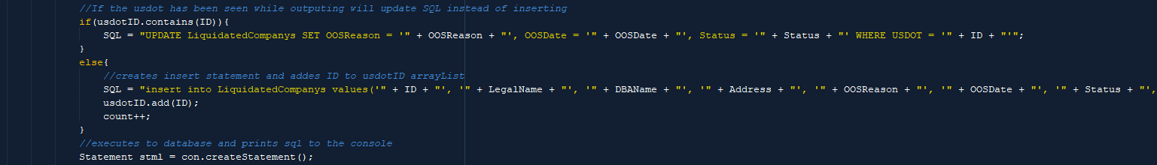

Strips data from online database

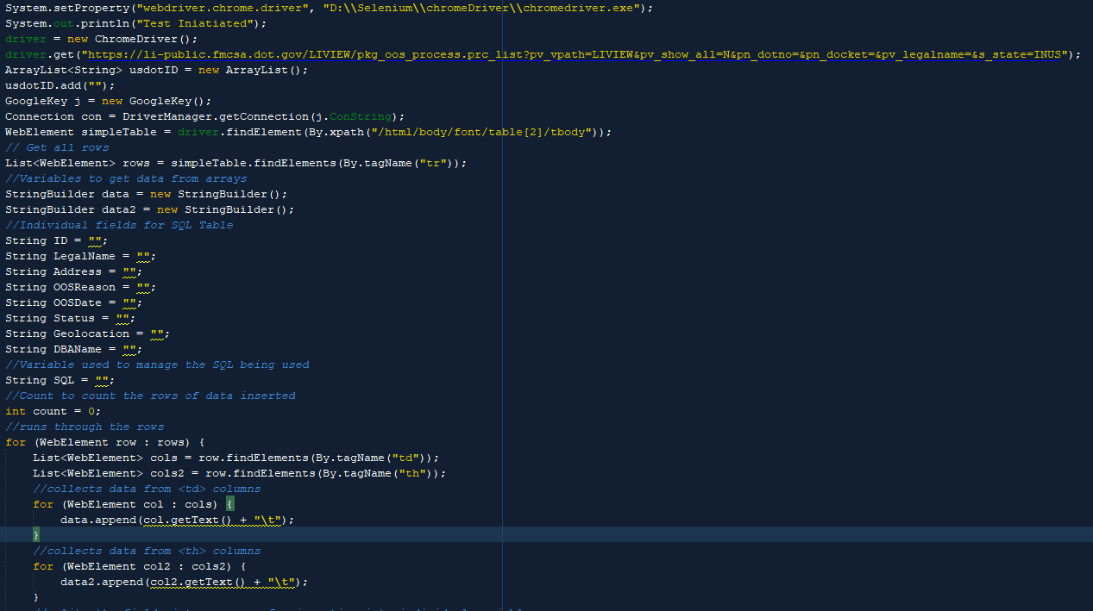

Takes data from database and puts it into a list to be compared